# Advanced Database Assignment.

Group Members

103428-Fredah Kioko

111878-Lilian Thairu

110785-Lydia Kahuria

Their posts

Lydia kahuria is the Director of finance.

Lilian Thairu is the grounds and operation Director

Fredah Kioko is the Sales and Marketing Director.

**BUSINESS-KITENGE GLAMOR**

Business Description

Kitenge Glamor is a textile manufacturing company that produces classic kitenge clotheslines and decorative shoes. Below is a porters value chain diagram that gives an understanding of the how the company operates.

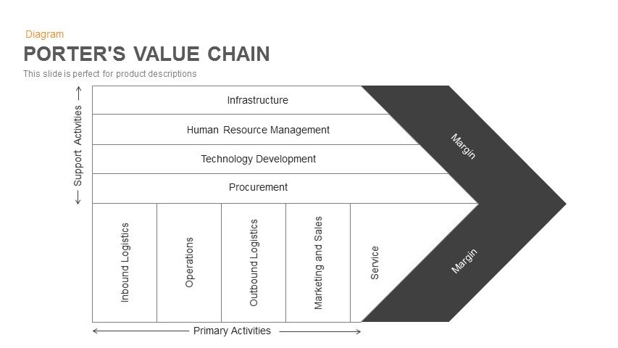

# Primary Activities

These functions contribute directly the competitive advantage of the business. They include :-

## Inbound Logistics

Here we shall explain the raw materials received and the inputs stored. Kitenge Glamour has various suppliers that receive the local purchase orders such as Nuria Kitenge that supplies the kitenge rolls, Bata that supplies the shoes, Kazuri that supplies the various decorative beads, Yarn manufactures that supplies them with sewing materials. All these materials are received and stored in the company’s warehouse located next to the industry and a delivery note is issued. The goods received note and the invoice is evaluated by (Lydia Kahuria) in the finance team and a cheque to the various suppliers is sent.

## Operations

The ground operations done her are overseen by me (lilian Thairu) and theyinclude procedures for converting raw materials into a finished product. The first process is the designers come up with various clothing and shoe designs including customer requests. Then the designs are handed to the tailors who sew and decorate the clothes manually using sewing machines. The various cobblers also manually sew kitenge pieces to the shoes decoratively. These activities usually occur in respect to the scheduled timelines. After these goals are achieved designers review the work and adjustments are made if any and the products are marked as ready. The clothes are then ironed if needed and the shoes are polished if need be and they are packaged.

## Outbound Logistics

This are the activities that include activities to distribute a final product to a consumer. The packaged goods are then transported to various retailers and sometimes directly to customers using company vehicles. Customers may also come by the factory to purchase various products

## Marketing and Sales

Kitenge Glamor has strategies to enhance visibility and target appropriate customers that are approved by Fredah Kioko’s team : such as advertising, promotion, and pricing. The company has an official website where online shoppers can view, buy and request products. Billboards that are strategically placed along major roads and YouTube adverts are also used to display the classic products. Sales made are then recorded.

## Services

The company offers payment services via m-pesa , credit card and cash upon buying goods. The company also offers repair services to those people who require that service but at a fee. They also exchange products for online shoppers that is if, for example, if a dress is small a bigger one is given to the customer. Customer care services are done via the website or sms incase of any complaints made by a customer.

# Support Activities

The support activities play an important role in coordinating and facilitating the primary value chain activities. Below is the analysis.

## Firm infrastructure

The

## Human resource management

## Technology Management

## Procurement